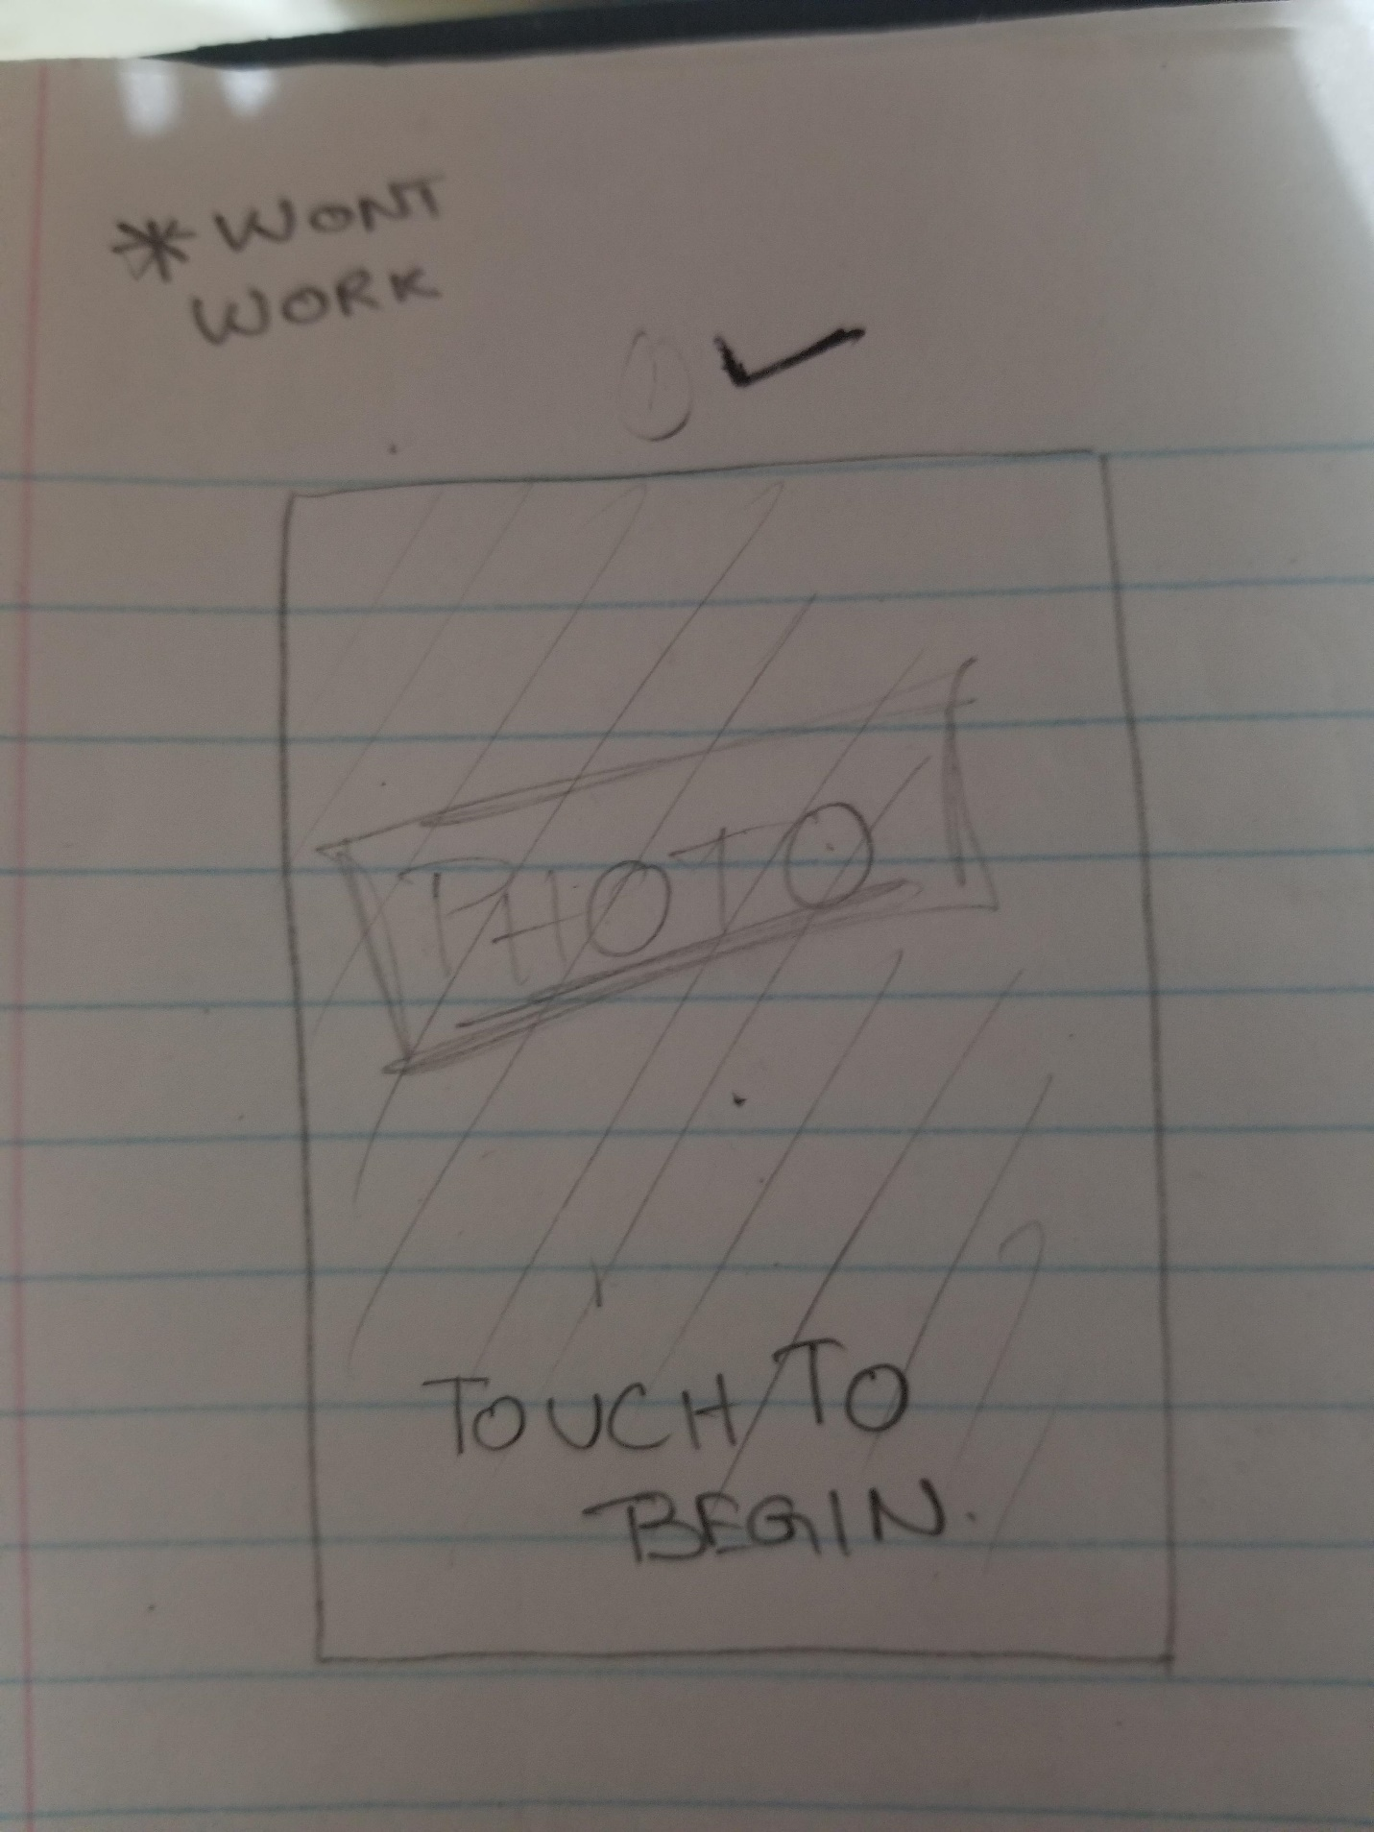

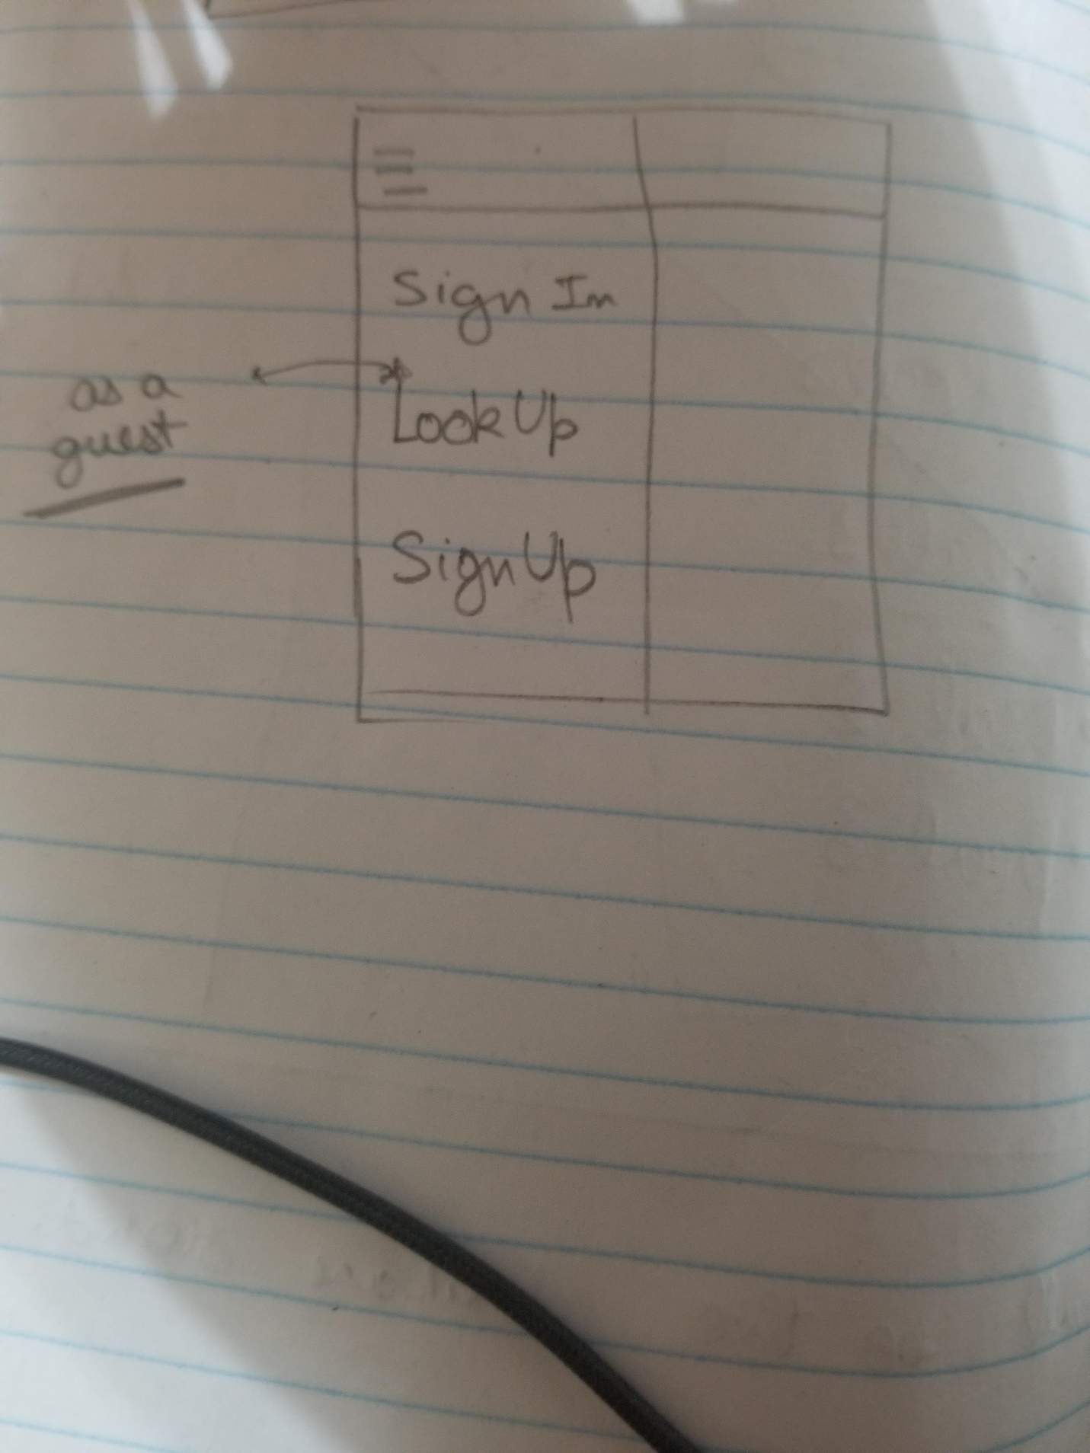

This screen will greet you with a drawer of these three options, what will be on the main screen is what we haven’t thought of yet but we will add something meaning full hear.

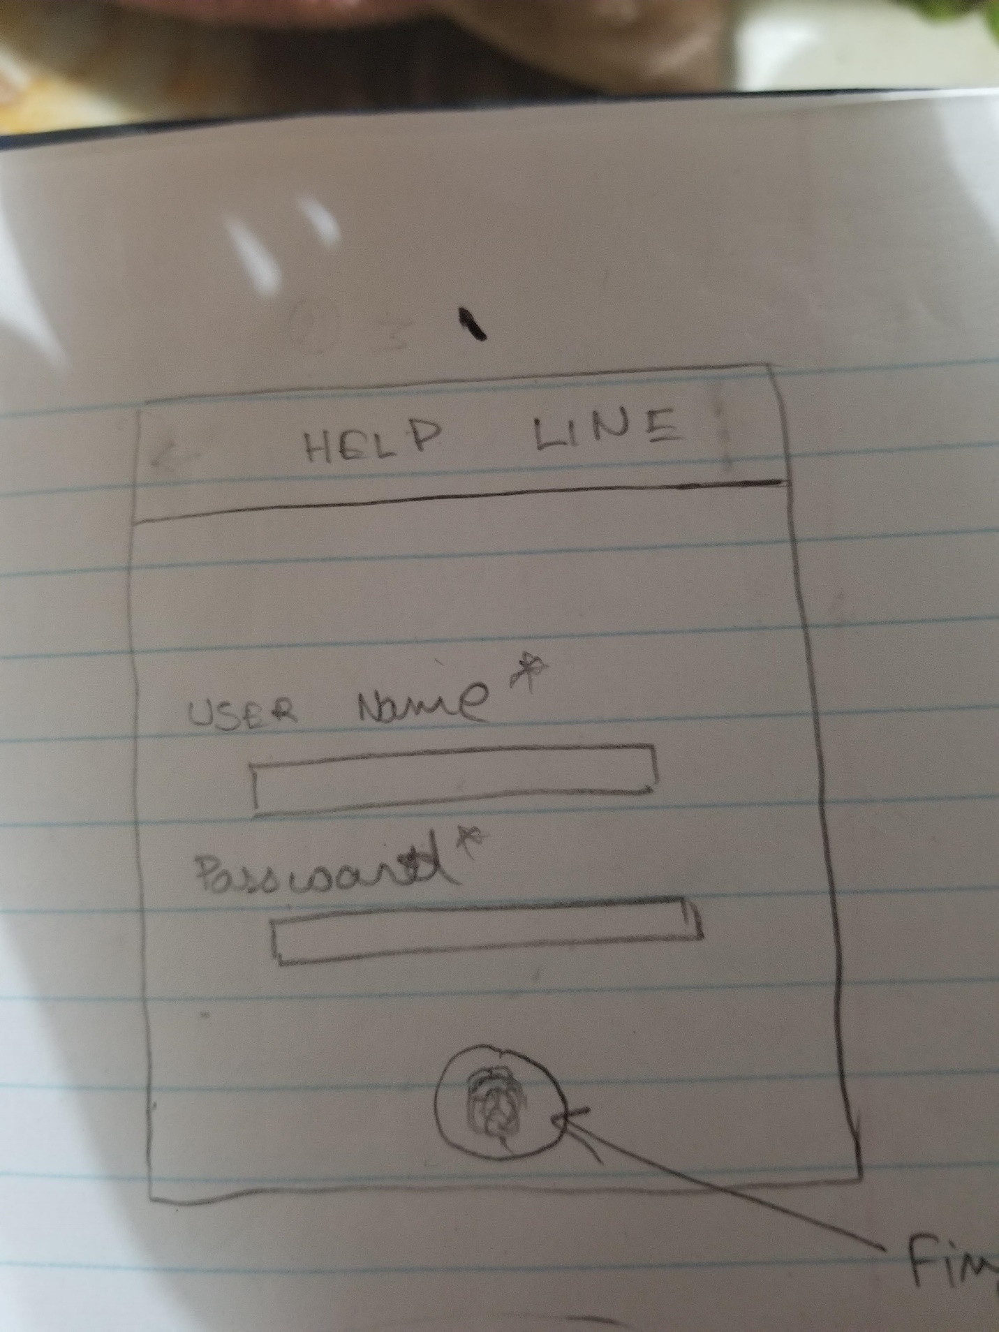

This is the login screen which will have the support fir fingerprint login.

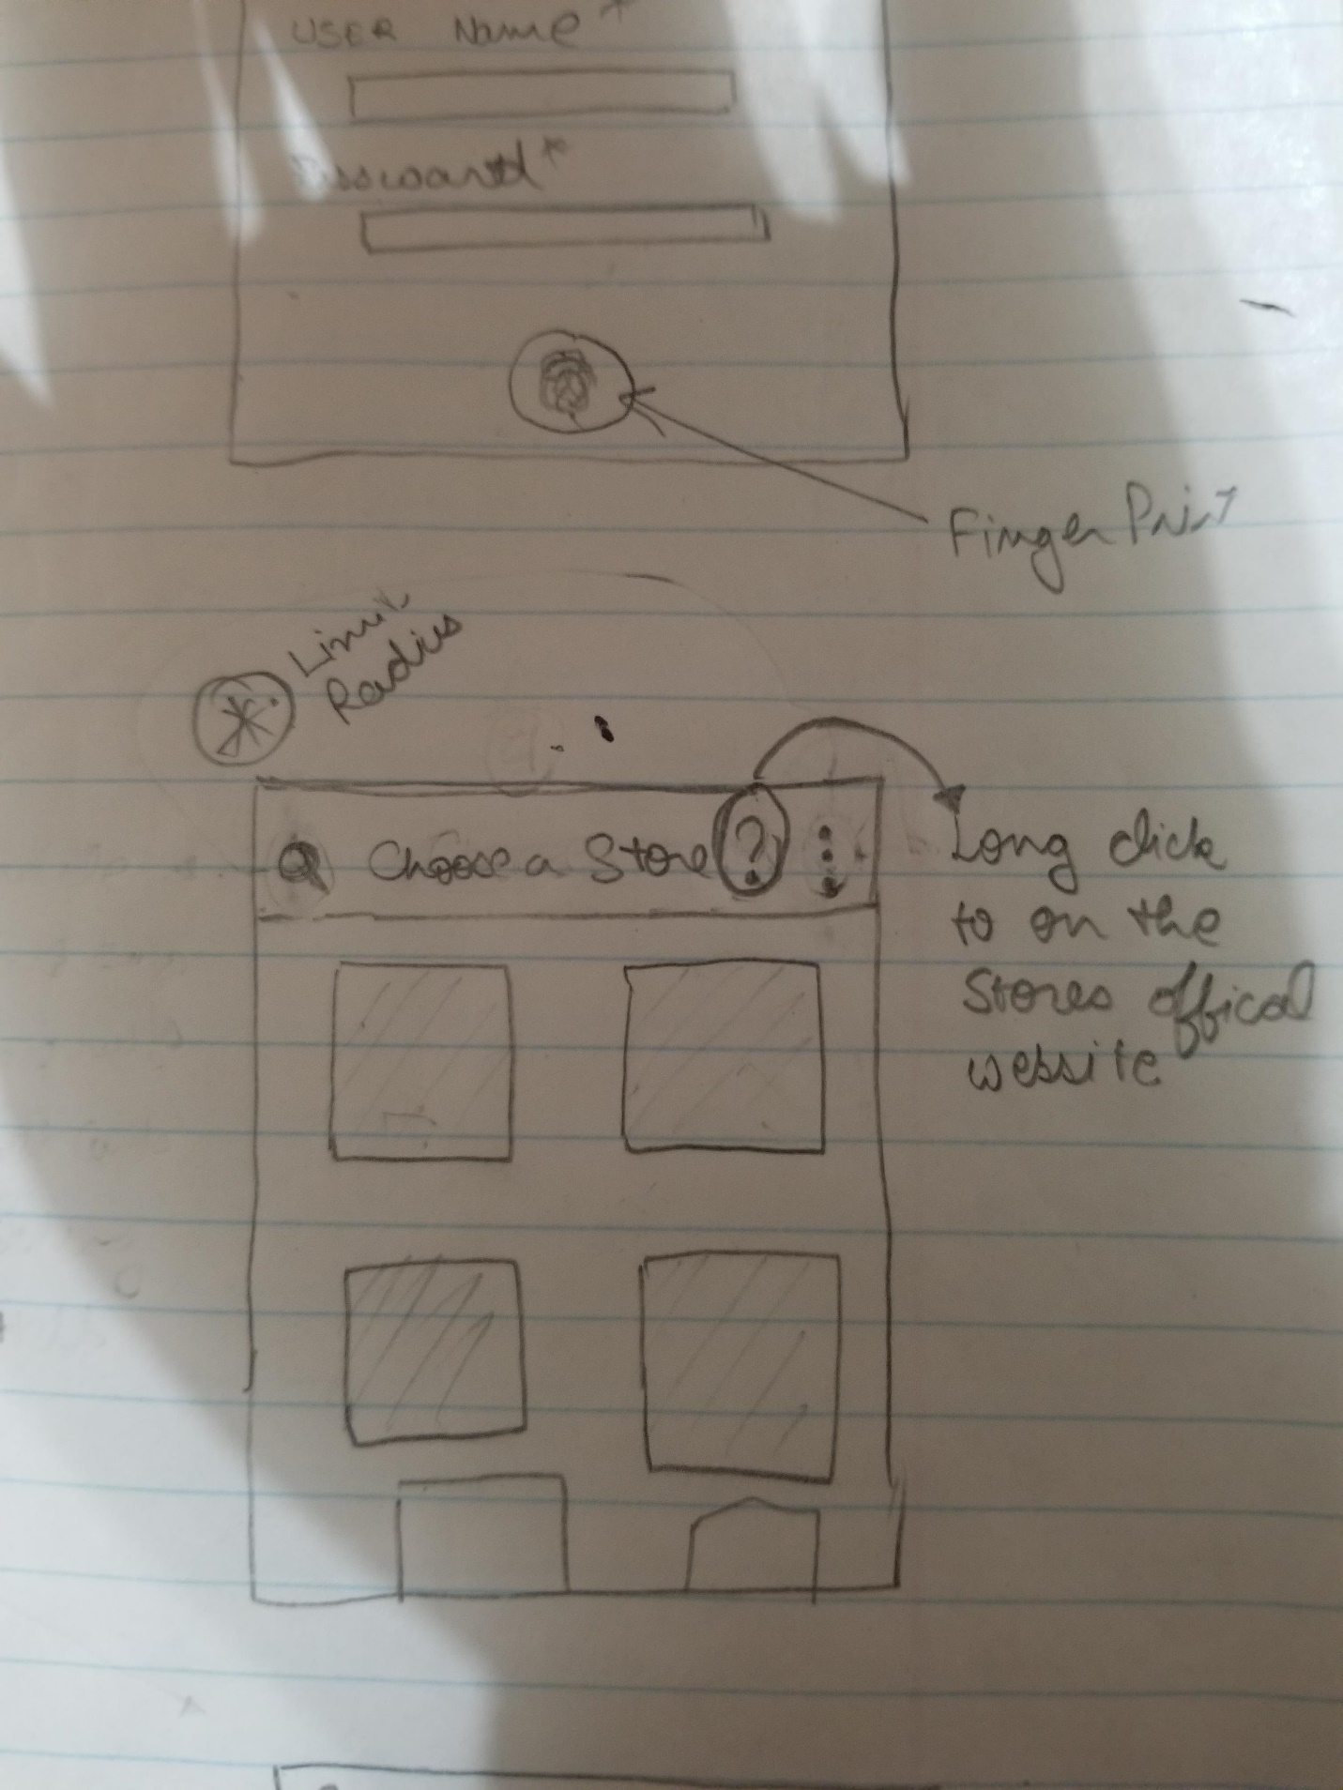

This screen will have the list of all nearby , supported stores. This search will use phone’s location.

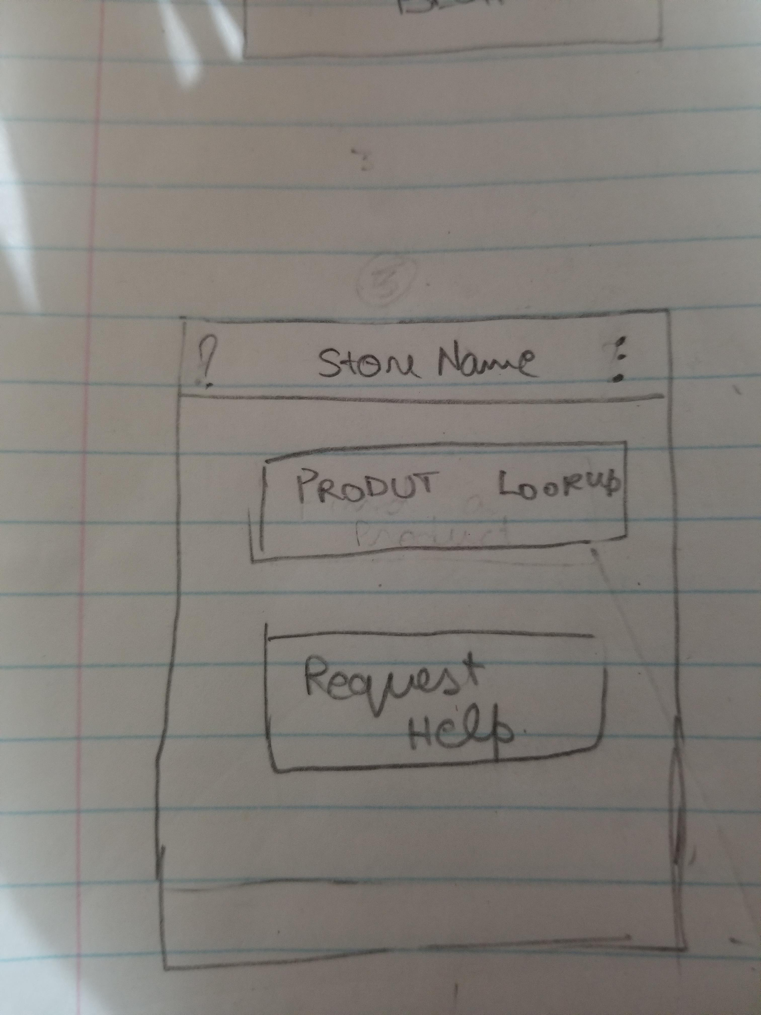

This is a pretty basic layout, just a transition between pages.

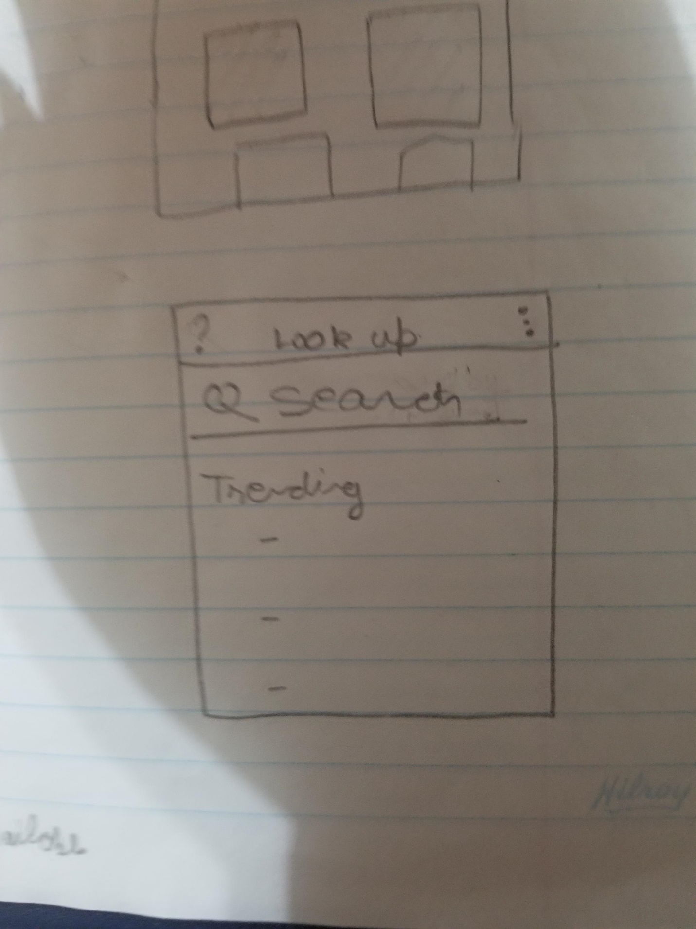

This will show up when the user clicks lookup, the trending over here will be the products that will pay us to keep their products in the trending category.

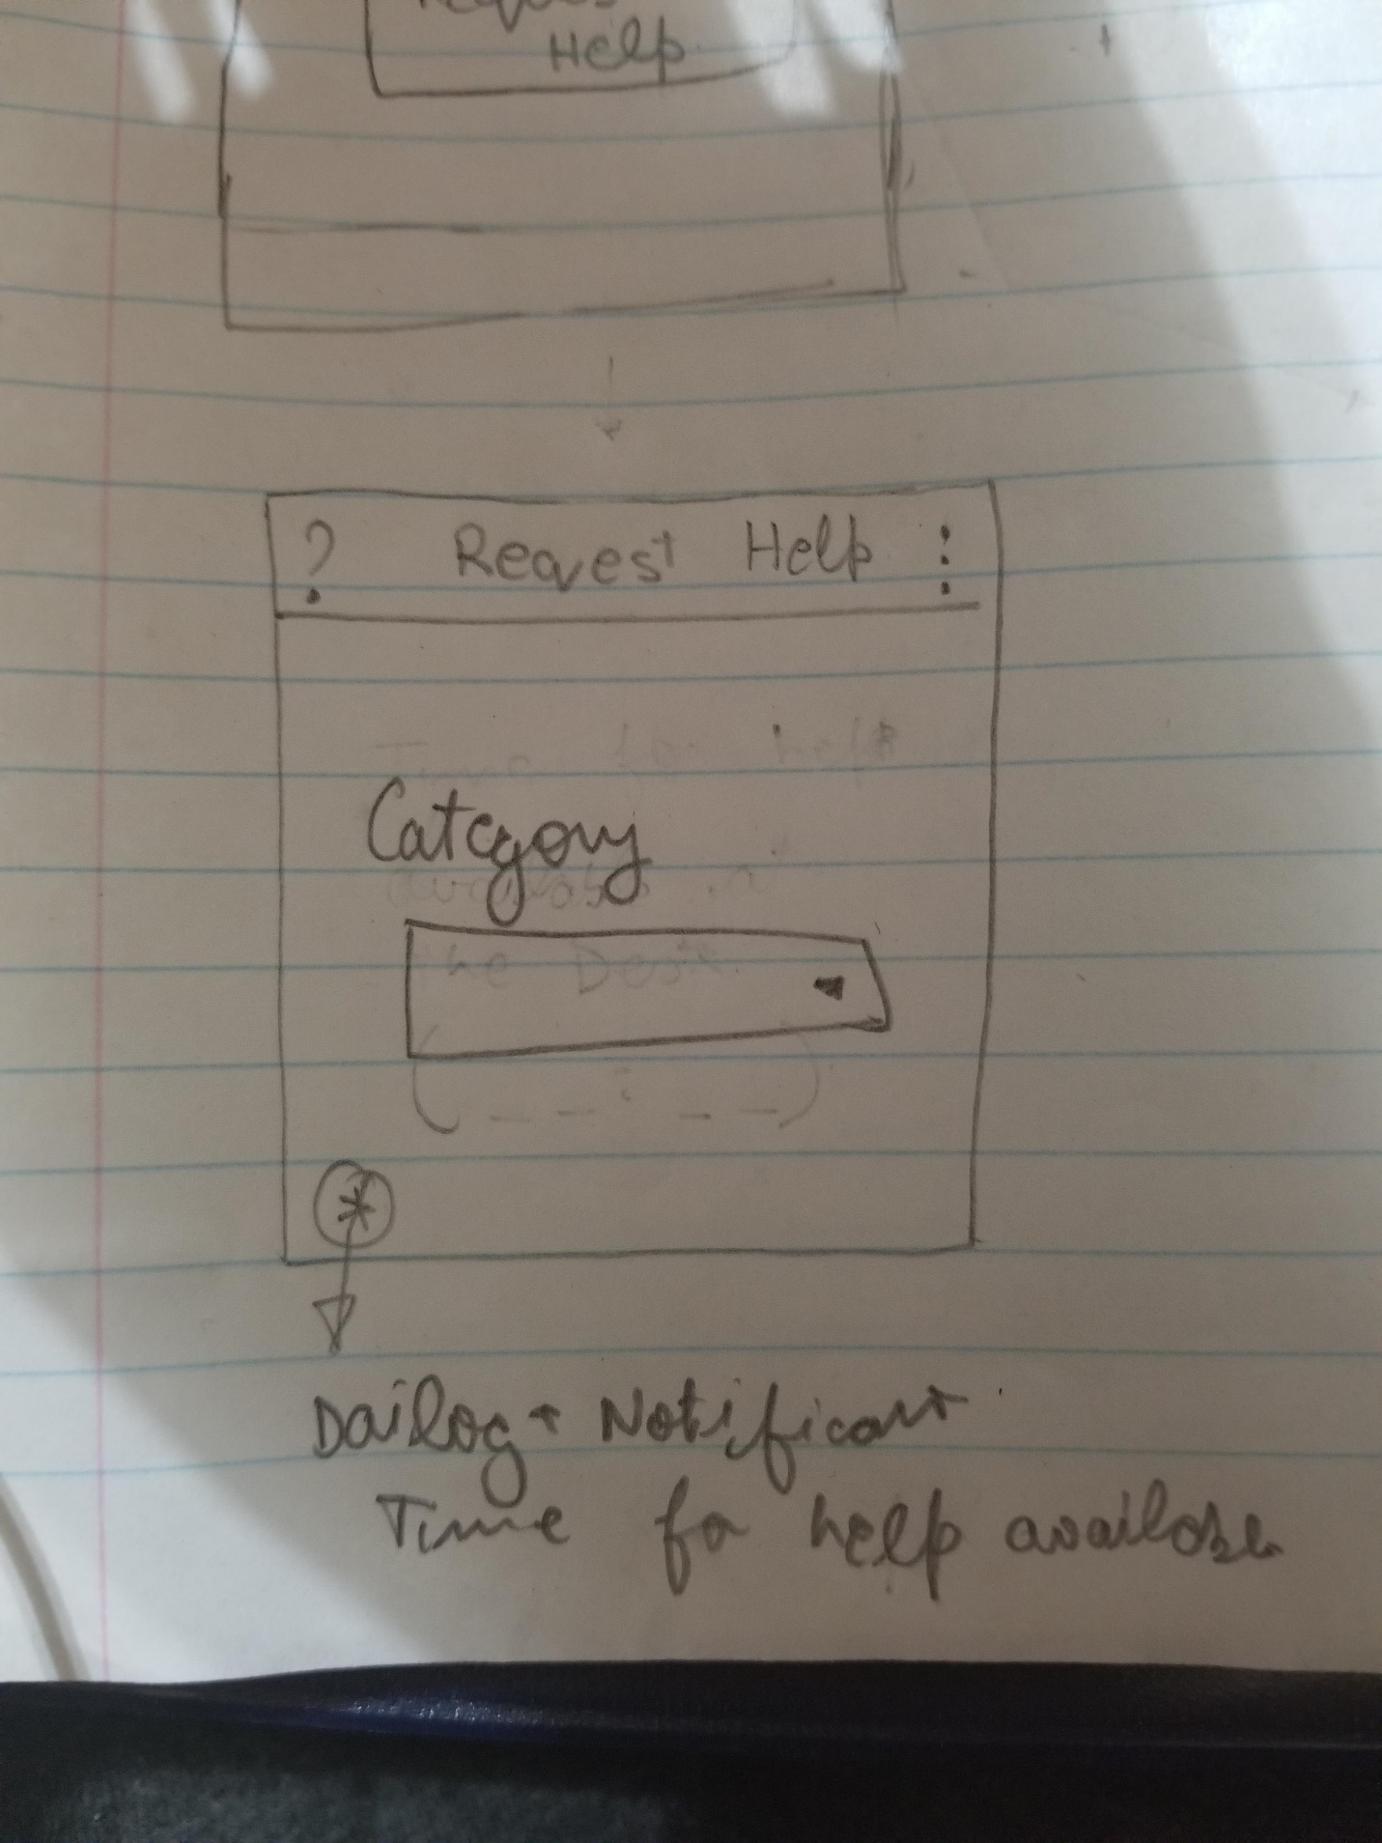

This screen will some when the user clicks request help.